Communication & Language
We will be describing our cars/bikes that we have at home using newly introduced vocabulary e.g. wing mirror, windscreen wiper, boot, handbrake etc.
Physical development
We will continue our daily handwriting sessions to form letters correctly. On Wednesday afternoons our PE sessions will continue. We will also practise our fine motor skills by using scissors and cutting tape.

Personal Social Emotional Development
Our focus this term is all about developing an understanding of who can help us both at home and in the community.
Magic Moments (Enrichment)
Bike day! Children can bring in their bikes from home.
Large scale train and aeroplane building in the playground.
Sharing photos of cars.

Spanish
We will be learning to say different types of transport in Spanish.

Subject Specific Vocabulary
Transport | Travel
Journey | Passport
Flight | Luggage
Sail | Tickets

Transport: How can we get there?
Year R Term 4

Literacy
We will be learning to use capital letters, full stops and finger spaces when writing sentences.
In Rocket Phonics we will be learning:
Digraphs and trigraphs – ch sh th ng ai ee igh oa oo
TRICKY WORDS he she we me be was they you are all my her
Maths
We will be learning number bonds to 10 and using this knowledge to help solve subtraction problems. We will also explore repeating patterns.

Expressive Arts and Design
We will construct models of different types of transport using a range of materials.
Exciting Books
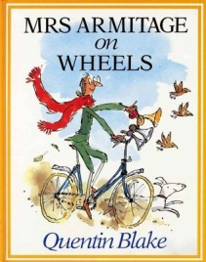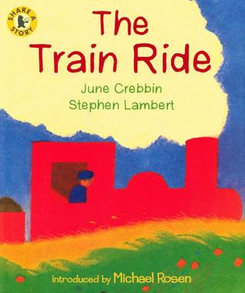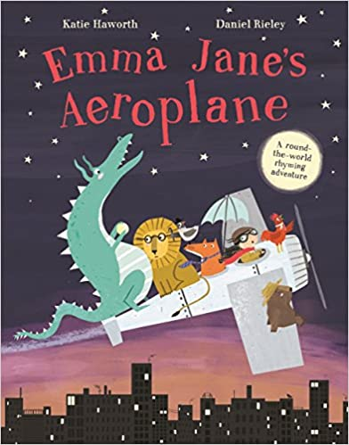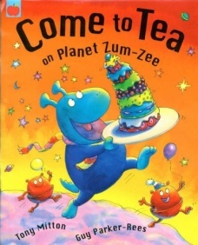
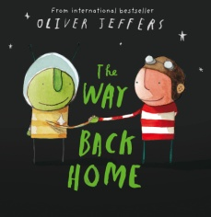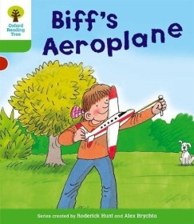
Understanding The World
We will compare different modes of transport looking at similarities and differences.

